Usage Requirements
Reference Level 2 UET for: _______________ Level 1 UET for: ________________

Note: This procedure shall be available to workers, though not necessarily at the work location. Refer to the procedure, as needed, to ensure the task is completed properly.

WORKING COPY (Revision Verified)
Initials | Date | Time | Initials | Date | Time | Initials | Date | Time

TABLE OF CONTENTS
1 PURPOSE 3
2 SCOPE 3
3 OTHER DOCUMENTS NEEDED 3
4 RESPONSIBILITIES 4
5 INITIAL CONDITIONS 4
6 TOOLS AND EQUIPMENT 4
7 PRECAUTIONS AND LIMITATIONS 4
7.1 Precautions 4
7.2 Limitations 5
7.3 Hazard Controls 6
8 PROCESS 7
8.1 Crane Operation 7
8.2 Cart Operation 10
8.3 Manually Operating C-1300 Air-Lock Doors 10

8.3.1 Manual Opening of C-1300 Air-Lock Doors 11

8.3.2 Manual Closing of C-1300 Air-Lock Doors 11

8.3.3 Restoring C-1300 Air-Lock Doors to Normal Operation 11
9 RECORDS 12
10 REFERENCES 12
11 DEFINITIONS 13
12 REVISION HISTORY 14
13 ATTACHMENTS 14
Attachment A, Side View of Cylinder Lift 15

PURPOSE
This procedure provides instructions for moving cylinders through the conversion process and out to storage using hoists, cranes, lifting frames, carts, and other lifting/moving devices.

SCOPE
The procedure applies to all cylinder types being moved through the conversion process and out to storage (e.g., feed, oxide, empty, and stabilized). DUF6 cylinder hoisting and rigging activities in the following area have been evaluated and determined to be ordinary lifts:
- 48" UF6 cylinder movement at the Full Cylinder Staging Area (FCS) using crane C-0-CHS-CN-001
- CV-12 cylinder movement at the Full Cylinder Staging Area (FCS) using crane C-0-CHS-CN-001
- 48" UF6 cylinder movement at VAP using crane C-0-CHS-CN-002
- CV-12 cylinder movement at VAP using crane C-0-CHS-CN-002
- 48" UF6 cylinder movement from north VAP to cylinder aging pad using crane C-0-CHS-CN-002
- 48" UF6 cylinder at OPH using cranes C-0-CHS-CN-003 or 004
- 48" UF6 cylinder movement at cylinder modifications using crane C-0-CHS-CN-005
- 48" UF6 cylinder movement at OPH loadout using crane C-0-CHS-CN-006
- 48" UF6 cylinder movement at cylinder stabilization using cranes C-0-CHS-CN-007 and 008
Exceptions:
This procedure does not address loading rail cars or trucks for off-site shipment.
This procedure does not apply to operation of the Cylinder Evacuation Room (CER) Cart (C-0-GEN-SP-104).

OTHER DOCUMENTS NEEDED
- DUF6-C-OPS-0507-F01, Cylinder Inspection Check Sheet
- DUF6 Form 3746, Overhead Crane, Monorail, and Jib Hoist Checklist
- DUF6 Form 3749, Lifting Fixture Checklist
- DUF6-U-SHP-0203-1, Hoisting and Rigging – Lift Determination and Type
- DUF6-U-SHP-0203-2, Hoisting and Rigging – Hoist Inspection and Operation
- DUF6-U-SHP-0203-3, Hoisting and Rigging – Overhead Crane Inspection and Operation
- DUF6-U-SHP-0203-4, Hoisting and Rigging – Sling, Rigging Equipment and Lifting Device Requirements
- HCIC-C-13-0499, Cylinder Movement Operations
- HCIC-C-14-0506, Depleted Uranium Hexafluoride Project General Hazard Analysis

RESPONSIBILITIES
Personnel responsible for performing this procedure:
    - Facility Manager
    - Operator Technician
    - General Maintenance Technician

INITIAL CONDITIONS
- IF a DUF₆ feed cylinder will be moved into the Vaporization System (VAP) Room or CER,
THEN that area is in OPERATION mode.
- Daily crane and lifting fixture inspections have been performed and recorded on DUF6 Form 3746, Overhead Crane, Monorail, and Jib Hoist Checklist and DUF6 Form 3749, Lifting Fixture Checklist.
- IF a remote crane controller will be used,
THEN controller number matches crane number.
- Cylinders to be moved have been identified by supervision.

TOOLS AND EQUIPMENT
- Slings with a minimum rated loading of 22,000 lbs
- Lifting devices/fixtures

PRECAUTIONS AND LIMITATIONS

Precautions
- All hoisting and rigging activities shall be performed per the following procedures:
DUF6-U-SHP-0203-1, Hoisting and Rigging – Lift Determination and Type
DUF6-U-SHP-0203-2, Hoisting and Rigging – Hoist Inspection and Operation
DUF6-U-SHP-0203-3, Hoisting and Rigging – Overhead Crane Inspection and Operation
DUF6-U-SHP-0203-4, Hoisting and Rigging – Sling, Rigging Equipment and Lifting Device Requirements
- Appropriate personal protective equipment (PPE) shall be worn at all times.
- Cart paths and rails, if applicable, shall be verified clear of any obstruction prior to energizing an electric cart or moving a manual cart.
- Avoid running over power cords and control cables with carts and prevent cords and cables from becoming entangled in other equipment. Also, dropping the power cable connector onto concrete could crack or break the connector.
- Extreme caution shall be used whenever working around the Autoclave Cradle or VAP Room Crane Transition (CT) Cart due to the following:
Pinch points
Elevated temperatures
Tripping hazards
Uneven floors
Diagonally-cut rail sections

Limitations
- Inventory Control:
The maximum inventory of uranium within each of the following facility segments shall be less than or equal to 35 DUF₆ Cylinder Equivalents.
- Conversion Building
- Full Cylinder Staging Area (FCS)
- Oxide Cylinder Staging Area (OCS)
- Empty and Heel Cylinder Staging Area (HCS)
DUF6-C-TSR-002, 5.5.3.2
- Non-standard feed cylinders shall be:
Attended by a fire-qualified individual during movement outside the Conversion Building.
Staged in the Non-Standard Cylinder Staging Area of the FCS when outside the Conversion Building.
DUF6-C-TSR-002, 5.5.3.3
- DUF₆ feed cylinders shall be staged in the FCS when outside the Conversion Building.
DUF6-C-TSR-002, 5.5.3.4I
- Previously breached and patched non-standard feed cylinders shall initiate processing in an autoclave within 30 days of being accepted at the Conversion Facility or be returned to the Cylinder Storage Yards.
DUF6-C-TSR-002, 5.5.3.3
- Previously breached and patched non-standard feed cylinders shall initiate processing in an autoclave 30 days of being removed from an autoclave following a process interruption or be returned to the Cylinder Storage Yards.
DUF6-C-TSR-002, 5.5.3.3
- Activities involving previously breached and patched non-standard feed cylinders containing greater than a heel amount of DUF₆ shall be limited to staging, handling/moving, or processing the cylinder contents.
DUF6-C-TSR-002, 5.5.3.3
- Only equipment approved by Engineering shall be used to move cylinders.
- Equipment with an out-of-date inspection shall not be used/operated.
- Movement of a CV-19 cylinder with the FCS bridge crane will require use of the 25-ton lifting fixture.
- Exterior hoisting and rigging activities will be suspended if sustained winds of greater than 25 mph or gusts greater than 30 mph are experienced.

Hazard Controls
- Task-specific hazards and hazard controls are identified in HCIC-C-13-0499, Cylinder Movement Operations.
- Potential surface contact with a thermal exposure > 130 F.
PPE: Long-sleeved cotton or flame resistant (FR)-rated garment and leather or cotton work gloves.
- Surface greater than 130 ºF can cause 1st degree burns in 5 seconds. The higher the temperature and the longer the skin contact, the more severe the burn. Warn personnel in the area of the hot surfaces of the danger. Cover or barricade hot surfaces if possible. Excessive manual force, manual handling of awkward loads, or one-person manual lift >45 lbs.
- Crane/hoist operation and/or rigging activities.
A lift type determination is required per procedure DUF6-U-SHP-0203-1, Hoisting and Rigging-Lift Determination and Type procedure PRIOR to conducting a lift.
Worker shall be hoisting and rigging trained and if operating a crane, the operator shall be qualified.
A formal written lift plan is required for critical and/or pre-engineered production lifts.
Slings & rigging devices shall be inspected prior to each lift.
Hard hats are required for personnel in the immediate vicinity of the hoisting and rigging activities.
- Radiological materials, contamination, or work occurring inside a controlled area and/or radiological area.
Personnel must be Radiation Worker II trained, briefed, and signed onto the appropriate RWP.
- General hazards and hazard controls are identified in HCIC-C-14-0506, Depleted Uranium Hexafluoride Project General Hazard Analysis.

PROCESS
Notes: | 1) | Attachment A, Side View of Cylinder Lift, may be referenced, as necessary.
 | 2) | Crane IDs are preceded by “C-0-CHS-“.

Crane Operation
Operator Technician or General Maintenance Technician
- Verify with the FM that cylinder movement will not exceed inventory limits of Step 7.2[1].
- Ensure routes for suspended loads are clear of equipment, combustibles, and personnel.
- IF moving a cylinder from FCS to VAP/CER,
THEN perform the following:
  - Inspect cylinder per DUF6-C-OPS-0507-F01, Cylinder Inspection Check Sheet.
  - Place DUF6-C-OPS-0507-F01, Cylinder Inspection Check Sheet, with DUF6-C-OPS-0100-F02, Cylinder Follower Card.
  - IF cylinder failed inspection,
THEN contact supervision.
- IF moving a cylinder out of Conversion Building,
THEN ensure Health and Safety Technician (HST) has performed required surveys.
- Ensure crane pendant/remote control is ON.
- IF cylinder movement is the first one performed on current shift,
THEN perform upper limit switch check by performing the following:
  - Raise hoist without load until switch activates.
  - IF switch does not operate correctly,
THEN contact supervision.
- Lower lifting fixture over cylinder.
WARNING
Since oxide cylinders (especially those that are not full) tend to shift during movement, additional care is needed when lifting.
Additional care is also needed for lifting cylinders after KOH liquid has been added at the Cylinder Stabilization Station. Even a small amount of liquid can cause a cylinder to tilt.
- Inspect lifting lugs to verify no cracks, pitting, or any other kind of deformation.
- IF moving a cylinder with the adjustable H-beam in CMS,
THEN perform the following:
  - Attach lifting fixture to cylinder lifting lugs AND ensure a secure connection.
  - Lift the cylinder an adequate amount to check for stability and for obstructions.
  - IF cylinder is adjusted to a stable level and will clear all obstructions,
THEN GO TO Step 8.1[12].
  - IF cylinder is unstable,
THEN repeat the following until the cylinder is stable and will clear all obstructions:
    - Lower the cylinder until there is slack in the slings.
    - Adjust the location of the lifting pin on the H-beam using the handwheel, socket, or similar tool.
    - Do not adjust the lifting pin more than 20” off center.
    - WHEN cylinder is adjusted to a stable level and will clear all obstructions,
THEN GO TO Step 8.1[12].
  - IF the cylinder cannot be adjusted to a stable level or will not clear all obstructions,
THEN contact supervision for further instructions.
- IF an oxide cylinder is to be lifted by lugs,
THEN perform the following:
  - Attach lifting fixture to cylinder lifting lugs AND ensure a secure connection.
  - Lift cylinder three to six inches to check center of gravity AND ensure no damage or deformation of lugs.
  - IF cylinder can be safely lifted by lugs,
THEN GO TO Step 8.1[12].
  - Lower cylinder AND disconnect lifting fixture from lifting lugs.
- IF cylinder is not to be lifted by lugs,
THEN perform the following:
  - Locate center of lifting fixture and hook above estimated center of gravity of cylinder.
  - IF cylinder lifting frame has sling legs attached,
THEN remove sling legs.
  - Place lifting slings under cylinder AND attach slings to lifting fixture using shackles on lifting frame.
  - Lift cylinder slightly.
  - IF cylinder is approximately level,
THEN GO TO Step 8.1[12].
  - Repeat the following until cylinder is approximately level or center of gravity is determined to be greater than 15 inches from geometric center of the cylinder:
    - Lower cylinder until slings are slack enough to be moved.
    - Position lifting equipment and slings to accommodate the estimated center of gravity.
    - Lift cylinder slightly.
  - IF center of gravity appears to be more than 15 inches from the geometrical center of the cylinder,
THEN contact Supervisor for further instructions.
- Raise cylinder AND move to desired location.
- Slowly lower cylinder to desired location.
- IF cylinder was not placed in saddle or cylinder cart,
THEN ensure cylinder is properly chocked.
- Disconnect lifting equipment from cylinder.
- IF cylinder movement is not completed,
THEN return to Step 8.1[1].
- Park the crane.
- Turn crane pendant/remote control off.

Cart Operation
Operator Technician or General Maintenance Technician
- IF not plugged in,
THEN plug in power cable.
- IF not connected,
THEN plug in pendant cable.
- Turn cart power ON.
- Ensure-STOP is not engaged.
Note: Step 5 may be repeated as necessary.
- Perform the following as necessary:
Position cart.
Load cylinder.
Move cart.
Lift cylinder.
- WHEN cylinder moves are complete,
THEN perform the following:
Turn cart power OFF.
IF outside,
THEN unplug pendant cable.

Manually Operating C-1300 Air-Lock Doors
- If the air-lock door cannot be immediately repaired on current shift (awaiting parts, etc) perform the following:
Warning
Doors are heavy and can be affected by a number of variables. Each door condition and use shall be evaluated. Evaluation and briefings will cover topics such as wind speeds, door chocks and chains, hydraulic operations, safe body positioning, physical exertion, pinch points, employee roles and responsibilities.
  - The evaluation will be made by the Facility Manager, Worker Representative, and HST-Safety/IH. If concurrence cannot be reached notify management for further instructions.
  - FM will provide two operators as deemed necessary by the evaluation to manually open and close the door. A third operator may be necessary to release the hydraulics while the door is being opened/closed.
  - A physical stop (door stop, chain, etc) will be available and used to keep the air-lock door in a stable/desired position. The physical stop will be identified during the pre-job brief and be available prior to manual door openings/closures.

Manual Opening of C-1300 Air-Lock Doors
- At the pump unit manifold, locate valves, F1, F2 and F3 fully opening them (counterclockwise).
Note: The button in the hydraulic control panel may have to be depressed to allow hydraulic fluid to travel freely in the line and the door to open and close easily.
- Manually push door open.

Manual Closing of C-1300 Air-Lock Doors
Note: The button in the hydraulic control panel may have to be depressed to allow hydraulic fluid to travel freely in the line and the door to open and close easily.
- Manually push door shut.
- At the pump unit manifold, locate valves, F1, F2, and F3 and close.
- Ensure door is latched when closed.

Restoring C-1300 Air-Lock Doors to Normal Operation
- At the pump unit manifold, locate valves, F1, F2, and F3 and close tightly by turning clockwise.
- Operate the air-lock door electrically one to two times to ensure all hydraulic lines are completely filled.

RECORDS
Records generated or received as a result of performing this procedure must be submitted to Document Management for retention and disposition in accordance with DUF6-U-DMP-0001, Controlled Document Procedure, and DUF6-U-DMP-0002, Records Management Procedure:
- DUF6-C-OPS-0507-F01, Cylinder Inspection Check Sheet
- DUF6 Form 3746, Overhead Crane, Monorail, and Jib Hoist Checklist
- DUF6 Form 3749, Lifting Fixture Checklist

REFERENCES
- C-0-CHS-LP-CN-001, Movement of 14T full cylinders (crane C-0-CHS-CN-001) at C-1745 full cylinder pad.
- C-0-CHS-LP-CN-001 CV12, Movement of CV-12 DUF6 Cylinders (crane # C-0-CHS-CN-001)
- C-0-CHS-LP-CN-002-a, 48" UF6 Cylinder Movement at VAP using crane C-0-CHS-CN-002
- C-0-CHS-LP-CN-002-b, Moving cylinders from north VAP to cylinder aging pad (crane C-0-CHS-CN-002)
- C-0-CHS-LP-CN-002 CV12, Movement of CV-12 DUF6 Cylinders (crane C-0-CHS-CN-002)
- C-0-CHS-LP-CN-003, 48" UF6 Cylinder Movement at OPH using cranes C-0-CHS-CN-003 or 004
- C-0-CHS-LP-CN-005, Lift cylinder onto modification stand using crane C-0-CHS-CN-005
- C-0-CHS-LP-CN-006, 48" UF6 Cylinder Movement at OPH loadout C-0-CHS-CN-006
- C-0-CHS-LP-CN-007, Moving 48 inch cylinders to and from the cylinder stabilization stations (crane C-0-CHS-CN-007 and 008)
- DUF6-C-TSR-002, Technical Safety Requirements for the DUF₆ Conversion Facility, Paducah, Kentucky
- OSHA Standard 29 CFR 1910.179, Subpart N, Overhead and Gantry Cranes

DEFINITIONS
CER Cylinder Evacuation Area
CT Crane Transition
DOE Department of Energy
DUF₆ depleted uranium hexafluoride
FCS Full Cylinder Staging Area
FR flame resistant
HCIC Hazard Controls Identification Checklist
HCS Empty and Heal Cylinder Staging Area
HST Health and Safety Technician
MCS Mid-America Conversion Services, LLC
OCS Oxide Cylinder Staging Area
PPE personal protective equipment
VAP Vaporization System
DUF₆ Cylinder Equivalent - Based on a U-235 assay of 0.707 wt%, a DUF₆ Cylinder Equivalent is any of the following:
One Model 48G DUF₆ cylinder containing a nominal weight of DUF₆ of 12.7 metric tons.
One Model 48G uranium oxide container.
20 55-gallon drums of uranium oxide.
85 heel cylinders.
DUF6-C-TSR-002, 1.2, 5.5.3.2
Attended – an object or activity is considered attended when a fire-qualified individual remains in visual contact with the object or activity, watches for abnormal conditions, is able to perform notification of emergency conditions per plant procedure, and has communication device.
DUF6-C-TSR-002, 1.2
Fire Qualified Individual – an individual who is trained as a fire watch, but who is not required to be independent from the work activity of concern and may concurrently monitor for fires and perform other duties.
DUF6-C-TSR-002, 1.2

REVISION HISTORY
Revision Number | Effective Date | Summary of Changes
0 | 1/10/18 | - Incorporated blue-sheet comments.  - Modified procedure to add an adjustable H-beam in CMS.  - Updated the HCIC.
1 | 05/10/18 | - Updated Section 2 Scope to include the reference to the lift plans associated with this procedure.  - Updated Section 10 Reference to include the lift plans.
2 | 09/16/19 | - Incorporated changes from DUF6-C-TSR-002, Rev. 15
3 | 10/24/19 | - Added Section for Manually Operating C-1300 Air-Lock Doors
4 | 08/26/21 | - Revised to allow the handling of CV-12 cylinders at FCSA and VAP.

ATTACHMENTS
Attachment A, Side View of Cylinder Lift

Attachment A, Side View of Cylinder Lift
Page 1 of 1
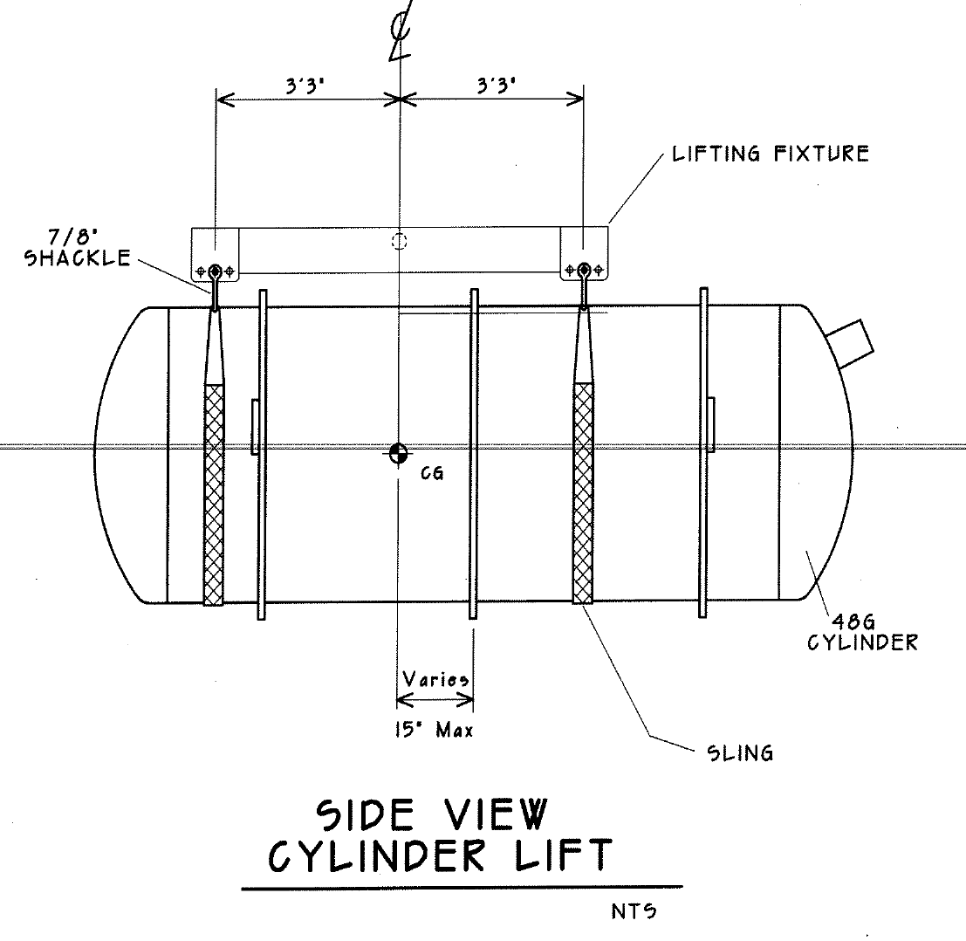
Typical
Typical
END OF DOCUMENT

