TITLE: In-Storage Inspection of 30” & 48” DOE UF6 Cylinders | DUF6-X-CYP-2502 | Rev. 2
DOCUMENT TYPE: Technical Procedure | PREPARER: M. Eberle | Page 1 of 16
SUBJECT MATTER AREA: Cylinder Yards | CONCURRENCE / DATE: See Form 4320.
OWNER: Logistics Manager | APPROVED BY / DATE: T. Warren / Refer to 4320.
_X_USQ Required __ Categorically Excluded | EFFECTIVE DATE: 02/24/2021
FORC REVIEW REQUIRED? __ Yes _X_ No | PERIODIC REVIEW: 2 years

Usage Requirements
Information Contained Within
DOES NOT CONTAIN
OFFICIAL USE ONLY EXPORT CONTROLLED INFORMATION
Reviewed by: Beth A. Hummel-Keener Date: 09/01/16

Reference Level 2 UET for: Attachments A, B, C__ Level 1 UET for: __________
Note: This procedure shall be available to workers, though not necessarily at the work location. Refer to the procedure, as needed, to ensure the task is completed properly.

Note: Attachments A, B and C must be under the control of the procedure user at the task location during periods of active performance. Each step or group of related steps of the procedure shall be read by the user or designated reader before performance of that step or activity. If procedure step sign-offs or data taking is required it shall be accomplished at the completion of the step.

DISCLAIMER
This document was prepared by Mid-America Conversion Services, LLC (MCS) under Department of Energy (DOE) Contract DE-EM0004559, and is intended for use solely in conjunction with the Depleted Uranium Hexafluoride (DUF₆) Conversion Project. The information contained herein shall not be disclosed, duplicated, or released in whole or in part for any purpose other than the DUF₆ Conversion Project without the express written consent of the U.S. DOE and MCS.
Information Contained Within
DOES NOT CONTAIN
OFFICIAL USE ONLY EXPORT CONTROLLED INFORMATION
Reviewed by: Beth A. Hummel-Keener Date: 09/01/16

Information Contained Within
DOES NOT CONTAIN
OFFICIAL USE ONLY EXPORT CONTROLLED INFORMATION
Reviewed by: Beth A. Hummel-Keener Date: 09/01/16

Information Contained Within
DOES NOT CONTAIN
OFFICIAL USE ONLY EXPORT CONTROLLED INFORMATION
Reviewed by: Beth A. Hummel-Keener Date: 09/01/16

Information Contained Within
DOES NOT CONTAIN
OFFICIAL USE ONLY EXPORT CONTROLLED INFORMATION
Reviewed by: Beth A. Hummel-Keener Date: 09/01/16

Information Contained Within
DOES NOT CONTAIN
OFFICIAL USE ONLY EXPORT CONTROLLED INFORMATION
Reviewed by: Beth A. Hummel-Keener Date: 09/01/16

Information Contained Within
DOES NOT CONTAIN
OFFICIAL USE ONLY EXPORT CONTROLLED INFORMATION
Reviewed by: Beth A. Hummel-Keener Date: 09/01/16

Information Contained Within
DOES NOT CONTAIN
OFFICIAL USE ONLY EXPORT CONTROLLED INFORMATION
Reviewed by: Beth A. Hummel-Keener Date: 09/01/16

Information Contained Within
DOES NOT CONTAIN
OFFICIAL USE ONLY EXPORT CONTROLLED INFORMATION
Reviewed by: Beth A. Hummel-Keener Date: 09/01/16

Information Contained Within
DOES NOT CONTAIN
OFFICIAL USE ONLY EXPORT CONTROLLED INFORMATION
Reviewed by: Beth A. Hummel-Keener Date: 09/01/16

Information Contained Within
DOES NOT CONTAIN
OFFICIAL USE ONLY EXPORT CONTROLLED INFORMATION
Reviewed by: Beth A. Hummel-Keener Date: 09/01/16

Information Contained Within
DOES NOT CONTAIN
OFFICIAL USE ONLY EXPORT CONTROLLED INFORMATION
Reviewed by: Beth A. Hummel-Keener Date: 09/01/16

TABLE OF CONTENTS

1 PURPOSE 3
2 SCOPE 3
3 OTHER DOCUMENTS NEEDED 3
4 RESPONSIBILITIES 3
5 INITIAL CONDITIONS 4
6 TOOLS AND EQUIPMENT 4
7 PRECAUTIONS AND LIMITATIONS 5
7.1 Precautions 5
7.2 Limitations 5
7.3 Hazard Controls 5
8 PROCESS 6
8.1 Preparing for Field Work 6
8.2 Cylinder Inspections 6
8.3 Closing Out Work Documentation 8
8.4 Post-Performance Actions 9
9 RECORDS 10
10 REFERENCES 10
11 DEFINITIONS 11
12 REVISION HISTORY 12
13 ATTACHMENTS 12
Attachment A, CID Generated DOE UF₆ Cylinder Information Database Inspection Requirements Detail with Defects 13
Attachment B, Alternate DOE 48-Inch Diameter & CV UF₆ Cylinder Inspection/Maintenance Checksheet and Instructions 14
Attachment C, Alternate DOE 30-Inch Diameter UF₆ Cylinder Inspection/Maintenance Checksheet and Instructions 15
Attachment D, Safe Standoff Distances 16

PURPOSE
This procedure provides directions for conducting baseline, periodic (daily, annual, quadrennial), and “special” visual in-storage inspections of 30-inch and 48-inch diameter U.S. Department of Energy (DOE) uranium hexafluoride (UF6) cylinders in long-term storage in DOE X-745C, X-745E, and X-745G cylinder storage yards.
DUF6-X-TSR-004, 5.5.3.3 A & B

SCOPE
This procedure applies to inspection of UF6 cylinders in long-term storage that are owned by the DOE and stored in the Portsmouth DOE X-745C, X-745E, and X-745G UF6 cylinder storage yards. This procedure applies to all models of DOE 30-inch and 48-inch cylinders.
Operator technician representation shall be included during the planning, execution, and closeout of UF6 cylinder-related work activities.

OTHER DOCUMENTS NEEDED
- CID Generated DOE UF6 Cylinder Information Database Inspection Requirements Detail with Defects
- DUF6-U-QAP-0005, Issues Management
- DUF6-U-CYP-0008, Decontamination of Non-Fissile UF6 and Non-PCB Cylinder Valves and Plugs and/or Shells
- DUF6-U-CYP-0001, Access Control For the Paducah And Portsmouth DOE UF6 Cylinder Storage Yards

RESPONSIBILITIES
Personnel responsible for performing this procedure:
- Logistics Manager
- Facility Manager
- Cylinder Yard Supervisor
- Cylinder Yard Operator Technician
- Cylinder Storage Yard (CSY) Administrative Assistant

INITIAL CONDITIONS
Note: The cylinder inspection periodicity should be based on cylinder history, cylinder handling activities, and environmental conditions to which the cylinder array is subjected.
The cylinder array should be arranged such that the cylinders can be viewed with sufficient ability as to determine the cylinder integrity. This may be accomplished with aisle spacing, periodic movement of cylinders, etc., but is left to the discretion of the Logistics Manager.
All cylinders containing greater than or equal to 1 wt. % ²³⁵U and greater than or equal to 15 grams ²³⁵U shall require periodic inspection for Nuclear Criticality Safety (NCS).
NCSE-SM-ER WM-006R06 #6.5.2
- Cylinder inspection frequency (daily, annual or quadrennial) has been determined and scheduled by the DOE UF6 Cylinder Information Database (CID).
- Periodic inspections shall be performed on fissile cylinders, according to CID, to verify cylinder integrity and to identify deteriorating cylinders.
DUF6-X-TSR-004, 5.5.3.3A&B
NCSE-SM-ERWM-006R06 #6.5.2
- Cylinder integrity may be verified by visual inspections of the cylinder walls to ensure there are no identifiable leakage paths for materials to enter into or exit from the cylinder.
Note: In the event of verified leakage paths, corrective measures shall be implemented as soon as practicable.
- IF any leakage paths are identified,
THEN corrective maintenance shall be performed.
DUF6-X-TSR-004, 5.5.3.3A&B
NCSE-SM-ERWM-006R06 #6.5.2

TOOLS AND EQUIPMENT
The following equipment may be needed during cylinder inspection. This list is not comprehensive and there is no requirement to have all this equipment in the cylinder yard during all activities.
- Mirror with extension
- Flashlight
- Ruler or straight edge
- Tape measure
- CID printout listing any cylinder defects
- Inspection Check sheets

PRECAUTIONS AND LIMITATIONS

Precautions
- No climbing on cylinders.
- If visible signs of PCB paint is observed on the ground, in the main isle, and/or within fifteen (15) feet on either side of the cylinder, then the observation shall be documented on the inspection report and the Cylinder Yard Supervisor notified.
- No casual contact with cylinder surfaces unless work activity is authorized by procedure and the Radiological Work Permit (RWP)..
- Standoff distances shall be maintained between UF6 cylinders and vehicles left unattended (i.e., when personnel are not within the CYLINDER STORAGE YARD). (See Attachment D, Safe Standoff Distances.)
DUF6-X-TSR-004, 5.5.3.4 D

Limitations
- Cylinder monitoring shall be implemented with appropriate corrective or preventive maintenance activities initiated to provide for containment of material within the UF₆ cylinder.
DUF6-X-TSR-004, 5.5.3.3A
- Cylinder monitoring shall be implemented with appropriate corrective and preventive maintenance activities initiated to provide for containment of material within the cylinder and exclusion of moderator (e.g., water) from cylinders containing fissile material and detection of degradation of the cylinder wall due to corrosion or other mechanisms.
DUF6-X-TSR-004, 5.5.3.3B

Hazard Controls
- General hazards are captured in HCIC-X-16-0639, Hazard Controls Identification Checklist (HCIC) for DUF6-X-CYP-2502, In-Storage Inspection of 30” & 48” DOE UF₆ Cylinders.

Process

Preparing for Field Work
Cylinder Yard Supervisor/CSY Administrative Assistant
- Use CID to identify cylinders due for inspection.
Cylinder Yard Supervisor
- Ensure all cylinders containing greater than or equal to 1% ²³⁵U enrichment and greater than a heel quantity of material are inspected at least every year.
- Ensure all cylinders containing UF6 that exceed 700g of fissionable material ²³⁵U and greater than or equal to 1% ²³⁵U enrichment are inspected following an earthquake at the site to ensure position shift has not occurred.
- Conduct pre-task briefing with all parties who will be working on or supporting the task.
Operator Technician
- Sign and Comply with applicable RWP.

Cylinder Inspections
Note: Cylinders in the cylinder yards do not require movement prior to in-storage inspection. Only those surfaces that are visible require inspection.
Operator Technician
- Review CID Generated "DOE UF₆ Cylinder Information Database Inspection Requirements Detail with Defects" form prior to performing a cylinder inspection to identify any previous defects.
WARNING
Climbing on cylinders while performing inspections may result in falls and severe injury.
- Evaluate material condition of each cylinder by performing visual inspection.
- Compare any identified defects against listed defect codes contained in Attachment B.
8.2 Cylinder Inspections (continued)
- Immediately Notify Cylinder Yard Supervisor of cylinders with defects represented by any of the following defect codes:
A01 - Hole in cylinder/evidence of visible leakage/contamination/reaction product
A13 - Crack in cylinder wall
B01 - Cylinder shell body in ground contact
B06 - Improper support
C01 - Evidence of leakage/contamination on valve
D01 - Evidence of leakage/contamination on plug
Cylinder Yard Supervisor
- IF cylinder has a structural defect represented by defect codes A01 (hole in cylinder/evidence of visible leakage/contamination/reaction product), A13 (crack in cylinder wall), B01 (cylinder shell body in ground contact), or B06 (improper upper tier cylinder support),
THEN Notify Facility Manager.
Facility Manager
- IF cylinder has a defect represented by defect code A01, A13, or B01 and cylinder is visibly leaking UF6,
THEN Notify Plant Shift Superintendent (PSS).
Cylinder Yard Supervisor
- IF any leakage paths are identified,
THEN Perform corrective maintenance.
DUF6-X-TSR-004, 5.5.3.3A&B
NCSE-SM-ERWM-006R06 #6.5.2
- IF 30-inch or 48-inch cylinder has a defect represented by defect code C01 and/or D01,
THEN Evaluate cylinder in accordance with DUF6-U-CYP-0008, Decontamination of Non-Fissile UF6 and Non-PCB Cylinder Valves and Plugs and/or Shells.
8.2 Cylinder Inspections (continued)
Note: Preventive maintenance checks/activities are addressed in DUF6-X-CYP-2520, Portsmouth UF6 Cylinder Maintenance Program.
- IF Cylinder Inspection Form with Defects indicates cylinder has defect(s) listed in Step 8.2 [4] or any other questionable defects,
THEN Perform the following:
- Contact MCS Engineering,
- OR Notify MCS Code Inspection to perform cylinder inspections per the applicable inspection procedures,
- AND Obtain a copy of the MCS Code Inspection Form.
- IF cylinder has a defect code of C01 or D01,
THEN Request HST perform a field evaluation.
- IF Code Inspection Form indicates that cylinder is rejected,
THEN Contact Facility Engineering to assess cylinder.
Facility Manager/Cylinder Yard Supervisor
  - Perform the following using Engineering's written assessments:
- Update CID,
- Initiate a Condition Report in accordance with DUF6-U-QAP-0005, Issues Management,
- Ensure cylinder is not returned to service.
- Repeat Steps 8.2 [1] thru [11] for each successive cylinder to be inspected.

Closing Out Work Documentation
Operator Technician
- Compare codes for each inspected cylinder to recorded codes contained on CID Generated “DOE UF₆ Cylinder Information Database Inspection Requirements Detail with Defects.”
  - IF there are no omissions,
THEN Go To step 8.3 [2].
8.3 Closing Out Work Documentation (continued)
  - IF there are any omissions of a previously identified defect code,
THEN Re-Examine cylinder.
  - IF code is not applicable after re-examination,
THEN Remove code on inspection completion.
- Enter inspection data from hard-copy DOE UF₆ Cylinder Information Database Inspection Requirements Detail with Defects into hand held tablets.
- Return completed DOE UF₆ Cylinder Information Database Inspection Requirements Detail with Defects to CSY Administrative Assistant/Cylinder Yard Supervisor.
Cylinder Yard Supervisor or Designee
- Review, Sign, and Date paper inspection check sheets.
- File original DOE UF₆ Cylinder Information Database Inspection Requirements Detail with Defects.
- Review and Approve inspection data in CID.

Post-Performance Actions
CSY Administrative Assistant/Cylinder Yard Supervisor
- Enter discrepancies discovered while inspecting cylinders, which require maintenance action, in CID within 10 working days.

RECORDS
Records generated or received as a result of performing this procedure must be submitted to Records Management and Document Control for retention and disposition in accordance with DUF6-U-DMP-0001, Controlled Document Procedure, and DUF6-U-DMP-0002, Records Management Procedure.
- CID Generated DOE UF₆ Cylinder Information Database Inspection Requirements Detail with Defects report, in accordance with site requirements

REFERENCES
- DUF6-U-CYP-0001, Access Control for the Paducah and Portsmouth DOE UF6 Cylinder Storage Yards
- DUF6-U-CYP-0002, DOE UF6 Cylinder Storage Yards Combustible Material Control Program
- DUF6-U-CYP-0008, Decontamination of Non-Fissile UF6 and Non-PCB Cylinder Valves and Plugs and/or Shells
- DUF6-U-CYP-0010, Paducah and Portsmouth UF6 Cylinder Storage Yard Management
- DUF6-U-DMP-0001, Controlled Document Procedure
- DUF6-U-DMP-0002, Records Management Procedure
- DUF6-U-QAP-0005, Issues Management
- DUF6-U-QAP-0022, Time Out/Stop Work
- DUF6-X-CYP-2520, Portsmouth UF6 Cylinder Surveillance and Maintenance Program
- NCSE-SM-ERWM-006R06, Storing and Handling Large Cylinders of Uranium Hexafluoride Material
- Ohio EPA Director's Final Findings and Orders, latest revision
- DUF6-PLN-040, Integrated Safety Management Plan
- DUF6-PLN-074, Worker Safety and Health Program
- DUF6-X-TSR-004, Technical Safety Requirements for the DUF₆ Conversion Project Cylinder Storage Yards, Piketon, Ohio
- Implementation of Additional Fire Controls Requirements Analysis, K-TSO-56, October 3, 1997
- Long Term Storage Cylinder Integrity Management Plan, WETO-114, Oak Ridge, Tennessee, September 1992
10 REFERENCES (continued)
- Methods and Results for Stress Analysis on 14-Ton, Thin-Walled Depleted UF6 Cylinders, ORNITM-13308, October 1996
- Uranium Hexafluoride: A Manual of Good Handling Practices, USEC-651
- DUF6-X-DSA-003, Documented Safety Analysis for the DUF₆ Conversion Project Cylinder Storage Yards, Piketon, Ohio

DEFINITIONS
CID DOE UF6 Cylinder Information Database
CII DOE UF6 Cylinder Computerized Inspection Interface
DFF&O Director’s Final Findings and Orders
DMSA DOE Material Storage Area
DOE Department of Energy
HF hydrogen fluoride
MCS Mid-America Conversion Services, LLC
NCS Nuclear Criticality Safety
NCSE Nuclear Criticality Safety Evaluation
PORTS Portsmouth Gaseous Diffusion Plant
ppm parts per million
PSS Plant Shift Superintendent
RWP Radiological Work Permit
TSR Technical Safety Requirement
ATTENDED - An object or activity is ATTENDED when a FIRE QUALIFIED INDIVIDUAL remains in visual contact with the object or activity, watches for abnormal conditions, is able to perform notification of emergency conditions per plant procedure, and is equipped with a communication device.
DUF6-X-TSR-004, 1.2 & 5.5.3.4 D
FIRE QUALIFIED INDIVIDUAL – An individual who is trained as a FIRE WATCH, but is not required to be independent from the work activity of concern and may concurrently monitor for fires and perform other duties.
DUF6-X-TSR-004, 1.2
Heel - The results from the transfer operation when a small mass of non-transferable material, known as the cylinder "heel," remains (25 lb. or less in a
30-inch cylinder and 50 lb. or less in a 48-inch cylinder).

REVISION HISTORY

Revision Number | Effective Date | Summary of Changes
0 | 02/28/17 | Implemented all global changes approved by MCS.
1 | 01/19/18 | Changed X-745G-1 to X-745G due to changes Cylinder Yard TSR document. Added Data Entry Clerk to section 4.
2 | 02/24/21 | - Periodic Review - Intent changes throughout document updating Cylinder Yard Manager to Logistics Manager and Data Entry Clerk to CSY Administrative Assistant.  - Updated inspection sheet title to DOE DUF₆ Cylinder Information Database Inspection Requirements Detail with Defects throughout procedure.  - Section 3 (and throughout procedure, if necessary)  - Deleted reference to cancelled documents, DUF6-X-OSU-002 and 003, and DUF6-U-CYP-0004.  - Updated procedure titles; DUF6-U-QAP-0005 and DUF6-U-CYP-0008  - Section 10 (and throughout procedure, if necessary)  - Updated procedure titles of DUF6-U-DMP-0001 and 0002, DUF6-PLN-040, and DUF6-X-TSR-004,  - Corrected procedure number of DUF6-U-QAP-0022.  - Updated Attachment B and title throughout procedure.  - Updated Attachment C and title throughout procedure.

ATTACHMENTS
Attachment A, CID Generated DOE UF₆ Cylinder Information Database Inspection Requirements Detail with Defects (Sample)
Attachment B, Alternate DOE 48-Inch Diameter & CV UF₆ Cylinder Inspection/Maintenance Checksheet and Instructions
Attachment C, Alternate DOE 30-Inch Diameter UF₆ Cylinder Inspection/Maintenance Checksheet and Instructions
Attachment D, Safe Standoff Distances

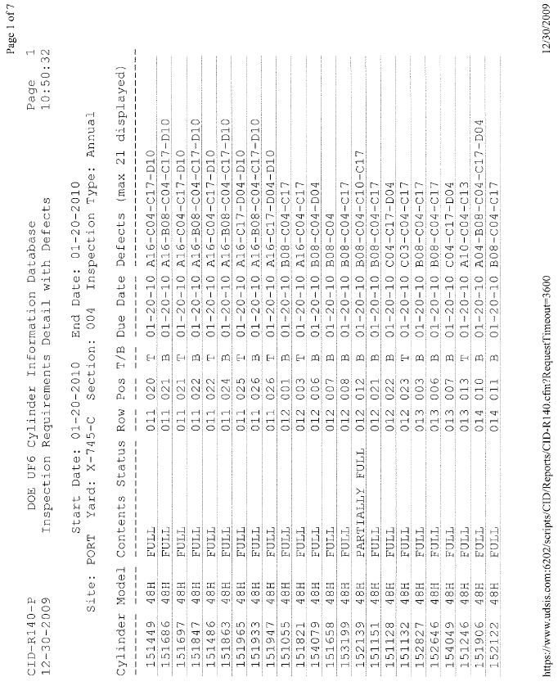
Attachment A, CID Generated DOE UF₆ Cylinder Information Database Inspection Requirements Detail with Defects Page 1 of 1

SAMPLE

Attachment B, Alternate DOE 48-Inch Diameter & CV UF₆ Cylinder Inspection/Maintenance

Checksheet and Instructions
Page 1 of 1
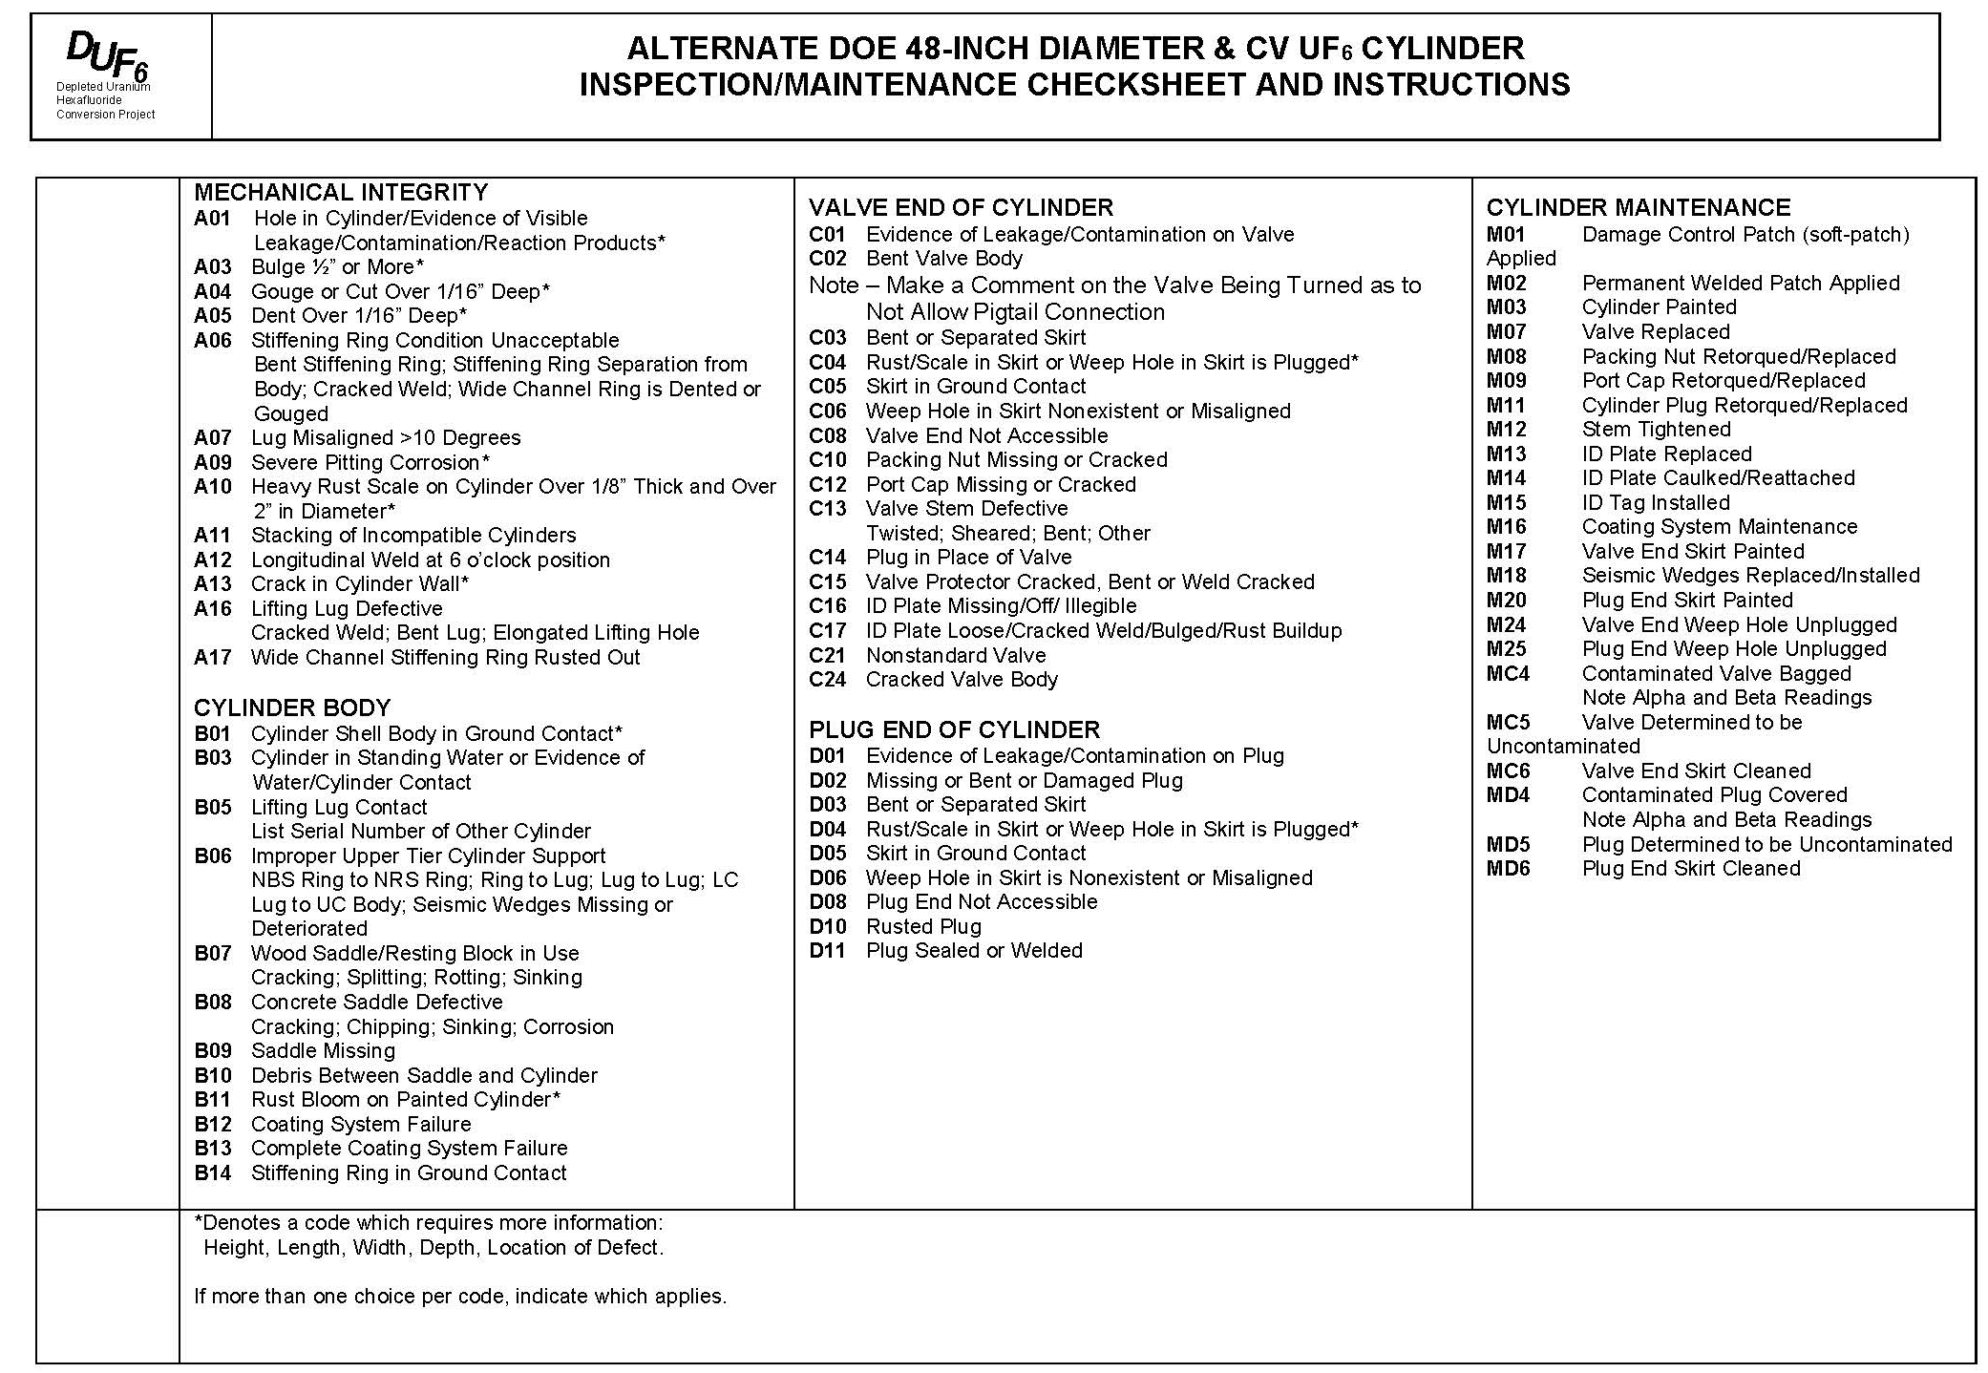

Attachment C, Alternate DOE 30-Inch Diameter UF₆ Cylinder Inspection/Maintenance Checksheet and Instructions
Page 1 of 1
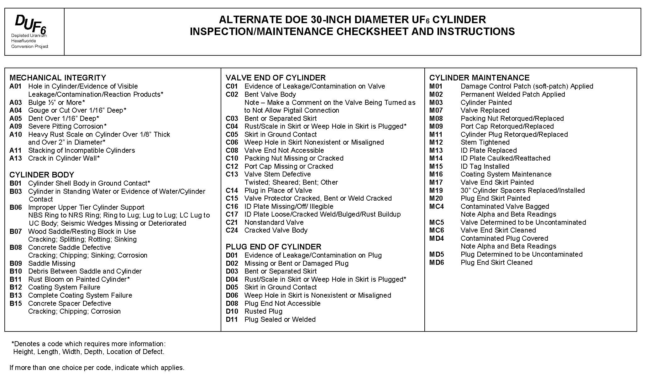

Attachment D, Safe Standoff Distances
Page 1 of 1

Safe Standoff Distances Between UF₆ Cylinders and Various Types of Unattended Vehicles/Equipment in the Cylinder Storage Yards
Vehicle/Equipment | Distance (ft)
Vehicles with greater than 250 and less than or equal to 450 gallons of fuel capacity | 40*
Vehicles with greater than 50 and less than or equal to 250 gallons of fuel capacity | 25*
Vehicles/equipment with less than or equal to 50 gallons of fuel capacity | 10*
* Applicable when personnel are not present in the Cylinder Storage Yard
DUF6-X-DSA-003, Table 4-3

END OF DOCUMENT

