TITLE: Transporting Uranium Oxide Cylinders | DUF6-X-CYP-2505 | Rev. 1
DOCUMENT TYPE: Technical Procedure | PREPARER: J. Anglemyer | Page 1 of 17
SUBJECT MATTER AREA: Cylinder Yards | CONCURRENCE / DATE: See Form 4320.
OWNER: Operations Support Manager | APPROVED BY / DATE: T. Marshall / Refer to 4320.
X USQ Required __ Categorically Excluded | EFFECTIVE DATE: 11/14/2018
FORC REVIEW REQUIRED? _X_ Yes __ No | PERIODIC REVIEW: 3 years

Usage Requirements
Reference Level 2 UET for: DUF6-X-CYP-2505-F01 and F02 Level 1 UET for: ___

Note: This procedure shall be available to workers, though not necessarily at the work location. Refer to the procedure, as needed, to ensure the task is completed properly.

Note: DUF6-X-CYP-2505-F01 and F02 must be under the control of the procedure user at the task location during periods of active performance. Each step or group of related steps of the procedure shall be read by the user or designated reader before performance of that step or activity. If procedure step sign-offs or data taking is required, it shall be accomplished at the completion of the step.

TABLE OF CONTENTS
1 Purpose 3
2 Scope 3
3 Other Documents Needed 3
4 Responsibilities 3
5 Initial Conditions 3
6 Tools and Equipment 4
7 Precautions and Limitations 4
7.1 Precautions 4
7.2 Limitations 4
7.3 Hazard Controls 4
8 Process 5
8.1 Cylinder Movement Preparations 5
8.2 Initial Lifting of the Cylinder 6
8.3 Transporting the Cylinder 7
8.4 Placing a Cylinder in the Bottom Storage Position 8
8.5 Placing a Cylinder in the Top Storage Position 9
8.6 Discovery of a Fluid Leak in Cylinder Handling Equipment 11
8.7 Response to a Dropped Cylinder 11
8.8 Post Relocation Activities 11
8.9 Closing Out Work Documentation 12
9 Records 13
10 References 13
11 Definitions 13
12 Revision History 14
13 Attachments 14
Attachment A DOE Oxide Cylinder Relocation Authorization Form 15
Attachment B Uranium Oxide Cylinder Transportation Routes 16
Attachment C Safe Standoff Distances 17

Purpose
This procedure provides instructions for transporting Department of Energy (DOE) cylinders containing uranium oxide between the DUF₆ Conversion Facility and the X-745 Cylinder Storage Yards (CSY). This includes pre-movement inspections and the placement of cylinders.

Scope
This procedure applies to the on-site transport of cylinders that have been filled with uranium oxide.
Transport of cylinders containing DUF6 is performed in accordance with applicable transportation requirements found in DUF6-U-CYP-2501, Handling, Transportation, and Inspection of DOE 48-Inch UF6 Cylinders.

Other Documents Needed
- DUF6-X-CYP-2505-F01, DOE Oxide Cylinder Relocation Authorization Form (CID or manually generated)
- DUF6-X-CYP-2505-F02, Inspection Criteria for Oxide Cylinders
- DUF6-X-CYP-2501, Handling, Transportation, and Inspection of DOE 48-Inch UF6 Cylinders
- DUF6-X-CYP-2513, Inspection and Operation of UF6 Cylinder Handler or Straddle Carrier
- DUF6-X-CYP-2519, Portsmouth Preventive Maintenance and Inspection Program for UF6 Cylinder Handling Forklifts

Responsibilities
Personnel responsible for performance of this procedure:
- CSY Supervisor
- CSY Operator / Technician
- Cylinder Data Management Clerk

Initial Conditions
Prior to initial use, cylinder-handling equipment used to lift, relocate, and transport cylinders shall be approved by Engineering and the site Cylinder Yard Facility Manager.

Tools and Equipment
The following equipment may be needed during oxide cylinder handling activities. This list is not comprehensive and there is no requirement to have all of this equipment in the cylinder yard during handling and inspection activities.
- Cylinder wedges
- Forklift
- Cylinder Handler
- Tools to set cylinder cradles

Precautions and Limitations

Precautions
- Leather gloves shall be worn when in physical contact with cylinders.
- Standoff distances shall be maintained between UF6 cylinders and vehicles left unattended (i.e., when personnel are not within the CYLINDER STORAGE YARD). (See Attachment C, Safe Standoff Distances.)
DUF6-X-TSR-004, 5.5.3.4 D
- Standoff distances shall be maintained between UF6 cylinders and vehicles left unattended (i.e., when personnel are not within the FULL CYLINDER STAGING AREA) per DUF6-X-OPS-0100, Cylinder Vaporization Production Order.
- Cylinder lift capacity shall be restricted to 31,654 lbs. maximum for the NCH-35 Stacker.
- If visible signs of PCB paint is observed on the ground then the Cylinder Yard Supervisor shall be notified and a work request initiated for cleanup.

Limitations
- Daily operating inspections on cylinder handler or straddle carrier shall be performed in accordance with DUF6-X-CYP-2513, Inspection and Operation of UF6 Cylinder Handler or Straddle Carrier.
- Oxide cylinders being moved to the Conversion Facility shall only be located in the Oxide Cylinder Staging Area (X-1745C).
- On-site speed limits shall not be exceeded.

Hazard Controls
- General hazards are captured in HCIC-X-16-0642, Hazard Controls Identification Checklist (HCIC) for DUF6-X-CYP-2505, Transporting Uranium Oxide Cylinders.

Process

Cylinder Movement Preparations
CSY Supervisor
- Prepare DOE Oxide Cylinder Relocation Authorization Form
(DUF6-X-CYP-2505-F01) either manually or automatically using the DOE
UF₆ Cylinder Information Database (CID) Database.
CSY Supervisor or Designee
- Enter cylinder ID into the CID for each oxide cylinder to be moved to or from CSY.
CSY Supervisor
- Notify Health and Safety Technician (HST) when oxide cylinder movements will be conducted.
- Ensure radiological survey has been performed of cylinder within past 72 hours.
Note: A pre-use inspection shall be performed each day the equipment is used.
WARNING
The cylinder handler operator shall be in the immediate vicinity of the equipment while it is running.
Cylinder Handler Operator
- Perform pre-use inspection of assigned cylinder-handling equipment in accordance with DUF6-X-CYP-2513, Inspection and Operation of UF6 Cylinder Handler or Straddle Carrier or DUF6-X-CYP-2519, Portsmouth Preventive Maintenance and Inspection Program for UF6 Cylinder Handling Forklifts, as applicable.
Operator Technician
- Verify handling equipment does not limit safe egress from work area.
8.1 Cylinder Movement Preparations (continued)
CSY Supervisor
- Ensure oxide cylinders are physically present on staging PAD.
Operator Technician
- Inspect cylinder to be transported using DUF6-X-CYP-2505-F02, Inspection Criteria for Oxide Cylinders.
- Immediately Notify Cylinder Yard Supervisor if any inspection criteria are ‘UNSAT’.
CSY Supervisor
- IF contamination is suspected,
THEN Perform the following:
  - Instruct Cylinder Handler Operator not to lift cylinder.
  - Initiate response actions in accordance with HST direction.

Initial Lifting of the Cylinder
Operator Technician
- Ensure there is safe egress from around cylinder.
- IF egress is not blocked by equipment or cylinders,
THEN Signal Cylinder Handler Operator to lift cylinder.
WARNING
Cylinder lift capacity shall be restricted to 31,654 lbs maximum for the NCH-35 Stacker.
- Lift cylinder using a straddle carrier or cylinder handler, as appropriate.

Transporting the Cylinder
Operator Technician
- Transport cylinder per the following:
Comply with requirements of DUF6-X-CYP-2501, Handling, Transportation, and Inspection of DOE 48-Inch UF6 Cylinders.
Use only approved transport routes shown in Attachment B, Uranium Oxide Cylinder Transportation Routes.
- Direct Cylinder Handler Operator to designated or assigned storage location for cylinder.
Cylinder Handler Operator
- Relocate cylinder, as directed by the Operator Technician.
Operator Technician
- Perform one of the following steps:
IF placing on saddle,
THEN Go To Section 8.4.
IF placing on top shelf of existing row,
THEN Go To Section 8.5.
IF placing on ground,
THEN Go To Step 8.3 [5].
- Perform the following to place cylinder directly onto ground:
  - Slowly Lower cylinder to surface, allowing cylinder to rest on its stiffening rings,
AND Wedge cylinder, if necessary.
  - Open grappler tines fully.
  - Raise and Move grappler from cylinder.
  - Apply wooden wedges to middle stiffing ring on both sides of cylinder.

Placing a Cylinder in the Bottom Storage Position
Cylinder Handler Operator
- Lower cylinder to horizontal position about six inches above saddles and centered on saddles.
Operator Technician
WARNING
Positioning any part of the body under a suspended cylinder is prohibited and could result in severe personal injury or death.
- Verify cylinder is aligned with saddles, being careful not to place any part of the body under the suspended cylinder.
- IF cylinder is not aligned,
THEN Signal Cylinder Handler Operator to reposition cylinder, being careful not to place any part of the body under the suspended cylinder.
- IF cylinder is in correct position,
THEN Signal Cylinder Handler Operator to lower cylinder onto saddles.
- IF any of the following do not exist,
THEN Reposition cylinder:
Cylinder body is centered and in contact with saddles.
Stiffening rings are not setting on a saddle.
Lifting lugs are approximately level or if the row is on a slope, parallel to slope of yard.
Flange ends are facing same direction in each row.
Lifting lugs are not touching neighboring cylinder.
Lifting lugs are similar in design and location to those of neighboring cylinder.
Cylinder Handler Operator
- IF cylinder handler is used,
THEN Perform the following:
  - Open grappler tines fully.
  - Raise and Move grappler from cylinder.

Placing a Cylinder in the Top Storage Position
WARNING
A struck-by/crushing hazard may exist if full 10-ton and 14-ton oxide cylinders are stacked more than three cylinders high.
Operator Technician
- Plan stacking to ensure stacked cylinder meets the following requirements:
Full 10-ton and 14-ton cylinders are not stacked more than three cylinders high.
Cylinder has same diameter and similar stiffening rings as bottom cylinders.
Cylinder type is compatible with cylinders it is to be stacked with.
Cylinder Handler Operator
- Lower cylinder to a position about six inches above bottom cylinders and centered above space between lower support cylinders.
Operator Technician
- Verify cylinder is aligned correctly with stiffening rings of lower-tier cylinders.
Cylinder Handler Operator
- Adjust position, as directed by the Operator Technician.
Operator Technician
- Signal Cylinder Handler Operator to lower cylinder onto lower cylinders.
- Position cylinder by ensuring the following:
  - Centerline of narrow/plate stiffening rings of upper cylinder are within approximately three inches of stiffening rings of lower cylinders.
  - Wide-channel stiffening rings of upper cylinder are supported by wide-channel stiffening rings of lower cylinders for at least half of their width.
  - Lifting lugs are not touching body of neighboring cylinders.
  - Bottom of top cylinder is not touching lifting lugs of bottom row cylinders.
  - Cylinder has a minimum of two contact points with each lower cylinder.

8.5 Placing a Cylinder in the Top Storage Position (continued)
Cylinder Handler Operator
- Slowly Lower cylinder onto lower cylinders.
- IF cylinder handler is used,
THEN Perform the following:
  - Open grappler tines fully.
  - Raise and Move grappler from cylinder.

Discovery of a Fluid Leak in Cylinder Handling Equipment
Cylinder Handler Operator
- IF cylinder-handling equipment is found to have a fluid leak during cylinder handling,
THEN Perform the following:
  - Lower cylinder to ground.
  - Back cylinder-handling equipment away from cylinder.
  - Shut Down engine.
  - Notify Cylinder Yard Supervisor and Facility Manager.
Cylinder Yard Supervisor
- IF event occurs outside cylinder yard or Oxide Staging Area,
THEN Perform necessary actions needed to protect cylinder from damage.
- Notify PSS of fluid leak, if applicable.
- Initiate clean up in accordance with site requirements.

Response to a Dropped Cylinder
Cylinder Handler Operator
- IF cylinder is damaged or dropped during handling or relocation,
THEN Stop and Notify Facility Manager and Cylinder Yard Supervisor.

Post Relocation Activities
Operator Technician
- IF oxide cylinder was relocated to a CSY,
THEN Record new cylinder storage location (Yard, Section, Row, Position, Top/Bottom) on DOE Oxide Cylinder Relocation Authorization Form.
- IF cylinder was relocated to the Conversion Facility,
THEN Record “X-1745C” under “Yard” on DOE UF₆ Cylinder Relocation Authorization form.
- Complete “Relocation Date” space for cylinder relocation on DOE Oxide Cylinder Relocation Authorization Form.

Closing Out Work Documentation
Operator Technician
- Return DOE Oxide Cylinder Relocation Authorization Form to supervision.
Supervisor
- Visually Verify locations of cylinders are correct.
- Sign DOE UF₆ Cylinder Relocation Authorization form.
Data Entry Clerk/Supervisor
- Update CID to reflect final location of cylinder(s).

Records
Records generated or received as a result of performing this procedure must be submitted to Records Management and Document Control for retention and disposition in accordance with DUF6-U-DMP-0001, Controlled Document Procedure, and DUF6-U-DMP-0002, Document Control and Records Management.
- DOE Oxide Cylinder Relocation Authorization Form, or equivalent
- Inspection Criteria for Oxide Cylinders

References
- Material Handling Equipment, 29 CFR 1926.602
- DUF6-X-TSR-004, Technical Safety Requirement for the DUF6 Conversion Project Cylinder Storage Yards, Piketon, Ohio
- DUF6-X-DSA-003, Documented Safety Analysis for the DUF6 Conversion Project Cylinder Storage Yards, Piketon, Ohio
- DUF6-X-OPS-0100, Cylinder Vaporization Production Order

Definitions
CID Cylinder Information Data Base
CSY DOE DUF₆ Cylinder Storage Yards
DOE Department of Energy
HST Health & Safety Technician
MCS Mid-America Conversion Services, LLC
NRTL Nationally Registered Testing Laboratory
PCB polychlorinated biphenyls
PORTS Portsmouth Gaseous Diffusion Plant
PPA Plant Protection Area
PSS Plant Shift Superintendent
TSR Technical Safety Requirement
U308 Uranium Oxide
ATTENDED - An object or activity is ATTENDED when a FIRE QUALIFIED INDIVIDUAL remains in visual contact with the object or activity, watches for abnormal conditions, is able to perform notification of emergency conditions per plant procedure, and is equipped with a communication device.
DUF6-X-TSR-004, 1.2 & 5.5.3.4 D
Empty – a cylinder with a net weight of zero.
11 DEFINITIONS (continued)
FIRE QUALIFIED INDIVIDUAL – An individual who is trained as a FIRE WATCH, but is not required to be independent from the work activity of concern and may concurrently monitor for fires and perform other duties.
DUF6-X-TSR-004, 1.2

Revision History
Revision Number | Effective Date | Summary of Changes
0 | 02/28/17 | Incorporated global changes approved by MCS.
1 | 11/14/18 | Formatting changes throughout procedure. Removed disclaimer on cover page. Added action step in section 8.1 for CSY Supervisor to ensure cylinder is present on staging PAD.

Attachments
Attachment A, DOE Oxide Cylinder Relocation Authorization Form (Sample)
Attachment B, Uranium Oxide Cylinder Transportation Routes
Attachment C, Safe Standoff Distances

Attachment A,
DOE Oxide Cylinder Relocation Authorization Form
Page 1 of 1
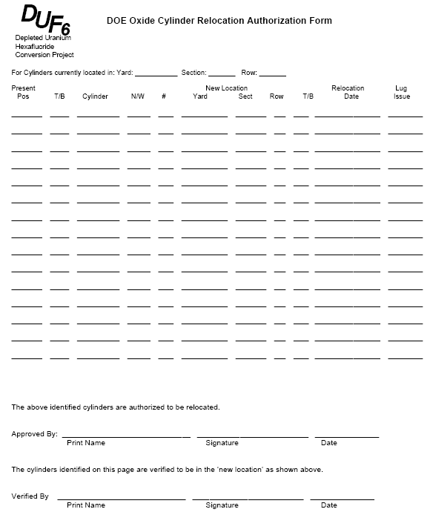
SAMPLE

Attachment B,
Uranium Oxide Cylinder Transportation Routes
Page 1 of 1
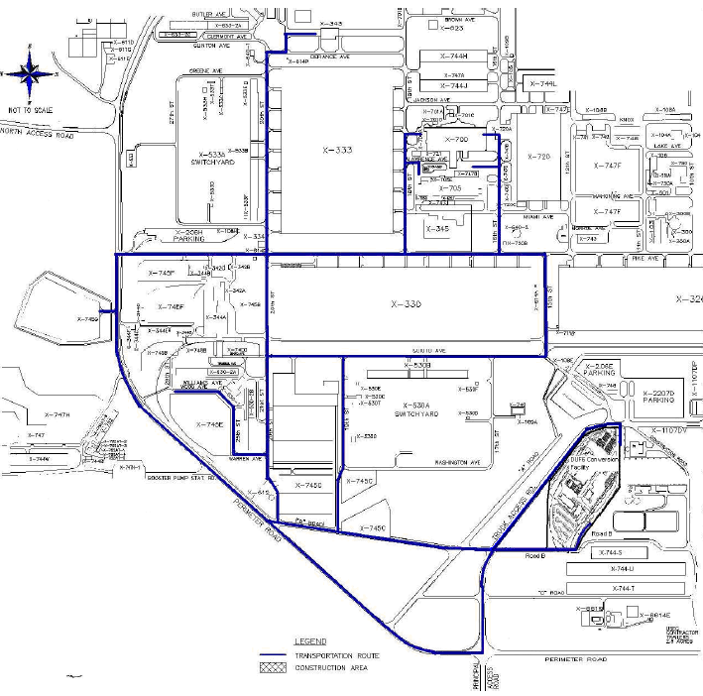

Attachment C,
Safe Standoff Distances
Page 1 of 1

Safe Standoff Distances Between UF₆ Cylinders and Various Types of Unattended Vehicles/Equipment in the Cylinder Storage Yards
Vehicle/Equipment | Distance (ft)
Vehicles with greater than 250 and less than or equal to 450 gallons of fuel capacity | 40*
Vehicles with greater than 50 and less than or equal to 250 gallons of fuel capacity | 25*
Vehicles/equipment with less than or equal to 50 gallons of fuel capacity | 10*
* Applicable when personnel are not present in the Cylinder Storage Yard
DUF6-X-DSA-003, Table 4-3

END OF DOCUMENT

