TITLE: Inspection and Operation of UF6 Cylinder Handler or Straddle Carrier | DUF6-X-CYP-2513 | Rev. 1
DOCUMENT TYPE: Technical Procedure | PREPARER: J. Anglemyer | Page 1 of 22
SUBJECT MATTER AREA: Cylinder Yards | CONCURRENCE / DATE: See Form 4320
OWNER: Logistics and Plant Support Manager | APPROVED BY / DATE: T. Marshall / See Form 4320
_X_USQ Required __ Categorically Excluded | EFFECTIVE DATE: 03/21/2019
FORC REVIEW REQUIRED? _X_ Yes __ No | PERIODIC REVIEW: 2 years

Usage Requirements
Reference Level 2 UET for: DUF6-X-CYP-2513-F01 Level 1 UET for: ________
Note: This procedure shall be available to workers, though not necessarily at the work location. Refer to the procedure, as needed, to ensure the task is completed properly.

Note: DUF6-X-CYP-2513-F01 must be under the control of the procedure user at the task location during periods of active performance. Each step or group of related steps of the procedure shall be read by the user or designated reader before performance of that step or activity. If procedure step sign-offs or data taking is required it shall be accomplished at the completion of the step.

TABLE OF CONTENTS

1 PURPOSE 3
2 SCOPE 3
3 OTHER DOCUMENTS NEEDED 3
4 RESPONSIBILITIES 3
5 INITIAL CONDITIONS 3
6 TOOLS AND EQUIPMENT 3
7 PRECAUTIONS AND LIMITATIONS 4
7.1 Precautions 4
7.2 Limitations 4
7.3 Hazard Controls 5
8 PROCESS 6
8.1 Preparing for Field Work 6
8.2 Cylinder Handling Equipment Inspection 6
8.2.1 Cylinder Handler or Straddle Carrier Inspection 6
8.2.2 Cylinder Handler Engine Operability Inspection 9
8.2.3 Straddle Carrier Engine Operability Inspection 10
8.2.4 Continued Equipment Inspection 12
8.3 Approval 14
8.4 Stacking Cylinders Using Cylinder Handlers 14
8.5 Moving Cylinders Using Straddle Carriers 16
8.5.1 Cylinder Pick Up and Transportation 16
8.5.2 Cylinder delivery 17
9 RECORDS 18
10 REFERENCES 18
11 DEFINITIONS 19
12 REVISION HISTORY 20
13 ATTACHMENTS 20
Attachment A, Cylinder Stacking Configuration 21
Attachment B, UF6 Cylinder Transportation Routes 22

PURPOSE
This procedure provides instruction for inspection and operation of cylinder handlers and straddle carriers. The cylinder handler or straddle carrier must be inspected before the first use during the shift, and found to be free of mechanical defects to ensure safe operation.
DUF6-X-TSR-004, 5.5.3.3 D

SCOPE
This procedure applies to the normal inspection and operation of uranium hexafluoride (UF6) cylinder handlers and straddle carriers at Portsmouth.
Mid-America Conversion Services, LLC (MCS) Form DUF6-X-CYP-2513-F01, Cylinder Handler/Straddle Carrier Inspection, shall be used in-hand, in parallel with the use of this procedure. This procedure is also applicable to trained operator-technician personnel involved in movement of non-liquid uranium-bearing cylinders with the cylinder handler or straddle carrier.
DUF6-X-TSR-004, 5.5.3.2 C

OTHER DOCUMENTS NEEDED
- DUF6-X-CYP-2513-F01, Cylinder Handler/Straddle Carrier Inspection

RESPONSIBILITIES
Personnel responsible for performing this procedure:
- Cylinder Storage Yard Facility Manager
- Cylinder Yard Supervisor
- Operator Technician
- Spotter

INITIAL CONDITIONS
- Equipment shall be inspected prior to use.
- Equipment preventive maintenance schedules shall be up-to-date.
- Personnel assigned to work in cylinder yards or operate cylinder-handling equipment shall be trained in accordance with the appropriate qualification requirements for the equipment.
DUF6-X-TSR-004, 5.5.3.2 C

TOOLS AND EQUIPMENT
- Leather gloves
- Rags (to be used for fluid checks or to clean off areas for inspection)
- Starting Fluid

PRECAUTIONS AND LIMITATIONS

Precautions
- Any step in this procedure that cannot be performed as specified requires the procedure user to stop and contact the Cylinder Yard Supervisor for direction.
- The vehicle operator shall always start and stop the vehicle smoothly and avoid sharp turns.
- The vehicle operator shall set the parking brake when leaving the cab.
- Fluid levels shall be checked daily, prior to first use, when engine is cool.
Engine Oil
Radiator Coolant
- The vehicle operator shall be aware of overhead obstacles during pick up, transport, and delivery of load.
- Caution shall be exercised at all rail road crossings.
- Cylinder lift capacity shall be restricted to 31,654 lbs maximum for the NCH-35 Stacker.

Limitations
WARNING
Cylinder Handling Equipment shall be attended by an Operator Technician
while it is running.
- An Operator Technician shall be used for a spotter when handling cylinders with the cylinder handler or straddle carrier.
- Cylinder handlers and straddle carriers shall be operated on concrete pads, approved road surfaces, and approved transportation routes only. Operation outside these areas requires the Cylinder Yard Supervisor's permission.
- Pre-operational checks shall be implemented on approved cylinder handling equipment to identify fuel, hydraulic, or lube oil leaks and initiate corrective or preventive maintenance.
DUF6-X-TSR-004, 5.5.3.3 D
- UF6 cylinder movements shall use trained drivers.
DUF6-X-TSR-004, 5.5.3.2 C
- All cylinder movements using UF6 Cylinder Handler or Straddle Carrier shall be in accordance with DUF6-X-CYP-2501, Handling, Transportation and Inspection of DOE 48-inch Diameter UF6 Cylinders or DUF6-X-CYP-2505, Transporting Uranium Oxide Cylinders.

Hazard Controls
- General hazards are captured in HCIC-X-16-0643, Hazard Controls Identification Checklist (HCIC) for DUF6-X-CYP-2513, Inspection and Operation of UF6 Cylinder Handler or Straddle Carrier.

PROCESS

Preparing for Field Work
Cylinder Yard Supervisor
- Conduct a pre-task briefing with all parties who will be working on or supporting the task.

Cylinder Handling Equipment Inspection
Note: Inspection steps may be completed in any logical order.

Cylinder Handler or Straddle Carrier Inspection
Operator Technician
- Record date and shift on DUF6-X-CYP-2513-F01, Cylinder Handler/Straddle Carrier Inspection.
- Record equipment number of equipment being inspected at top of
DUF6-X-CYP-2513-F01.
- IF a deficiency is discovered during the inspection,
THEN Perform the following:
  - Immediately Report deficiency to Cylinder Yard Supervisor.
  - IF corrective action is taken,
THEN Explain action taken in “Remarks” section on
DUF6-X-CYP-2513-F01.
  - IF corrective action cannot be taken,
THEN Immediately Report corrective action problem to Cylinder Yard Supervisor.
- Walk completely around cylinder handler or straddle carrier to ensure no obstacles have been placed in the path of travel.
Note: After each inspection on Steps 8.2.1 [5] through [8], the appropriate box shall be marked on DUF6-X-CYP-2513-F01 to indicate the results of the inspection.
- Inspect for damage, general appearance, and potential structural damage (such as cracked welds).
- Visually Inspect tires for cuts, bulges, bruises, tire-tread wear, improper tire pressure, and wheel nuts in place.
- Visually Inspect chain drive, wheels, and guards, if equipped.

8.2.1 Cylinder Handler or Straddle Carrier Inspection (continued)
- Inspect fire extinguisher to verify acceptable operating pressure.
- IF cylinder handler is being inspected,
THEN Turn battery switch “ON”.
- IF HYSTER 400 Straddle Carrier is being inspected,
THEN GO TO Step 8.2.1[13].
WARNING
A 3-point contact shall be maintained while climbing onto equipment to prevent serious injury.
- Visually Inspect engine oil as follows:
  - Remove dirt or foreign matter that may contact outside of dipstick before removing dipstick from guard tube.
  - Check oil level when engine is cold (before starting), if possible.
  - Mark appropriate box on DUF6-X-CYP-2513-F01.
- Visually Inspect hydraulic oil as follows:
  - IF vehicle is equipped with hydraulic fluid gauge,
THEN Perform the following:
    - Ensure engine is running.
    - Verify needle is in normal operating range.
    - Mark appropriate box on DUF6-X-CYP-2513-F01.
    - Go To Step 8.2.1 [13].
WARNING
NCH-35 hydraulic oil tanks are pressurized. To prevent personnel injury vent valve should be opened to release pressure and closed before removing dipstick.
  - Ensure engine is not running,
AND Remove dirt or foreign matter in contact with outside of dipstick before removing dipstick from guard tube.
  - Check oil level with dipstick,
AND Mark appropriate box on DUF6-X-CYP-2513-F01.
- Ensure gauges for engine oil, hydraulic oil and coolant are within operating parameters (HYSTER 400 Straddle Carrier only).
8.2.1 Cylinder Handler or Straddle Carrier Inspection (continued)
WARNING
Removing the radiator cap when engine is operating or when the engine is warm, may cause personnel injury or equipment damage.
- Visually Inspect coolant as follows:
  - Verify engine is not hot.
  - Remove radiator cap.
  - Check coolant level.
  - Ensure radiator or expansion tank is filled to proper level.
  - Mark appropriate box on DUF6-X-CYP-2513-F01.
Note: Supervision shall be notified when cylinder handler fuel level decreases to ¼ tank.
WARNING
Smoking or open flame near an open fuel tank may cause personnel injury or equipment damage.
- Ensure vehicle has adequate fuel for job assignment,
AND Mark appropriate box on DUF6-X-CYP-2513-F01.

- Adjust seat (to access controls), safety belt, and mirrors.
- Check preventive maintenance due date and monthly inspection due date AND Note result on DUF6-X-CYP-2513-F01.
- Confirm power light on Fire Suppression System Panel is flashing green (located on lower right side of cabinet),
AND Mark appropriate box on DUF6-X-CYP-2513-F01.
- IF inspecting straddle carrier,
THEN Go To Step 8.2.3.

Cylinder Handler Engine Operability Inspection
Operator Technician
Note: When ignition key is placed to ON, a buzzer will be heard and a red “NOT SAFE TO OPERATE” light will illuminate until air pressure increases above 60 psig.
- Place ignition key to ON.
- Verify emergency brake light and circuit light illuminate.
- Ensure parking brake is applied (to prevent vehicle from moving during an inspection) and transmission is in neutral.
WARNING
The cylinder handler shall be attended while it is running.
- IF weather is mild or engine is still warm,
THEN Go To Step 8.2.2 [6].
- IF weather is cold,
THEN Spray starting fluid in air intake for approximately two seconds.
Caution
Engaging the starter for more than 15 seconds may cause equipment damage. Starter damage may occur if starter is not allowed to cool between starting attempts.
- Place ignition key to START,
AND Release when either of the following occurs:
Engine starts
15 seconds have passed
Caution
If oil pressure does not increase within approximately 10 seconds after start or drops to zero during operation, the engine shall be stopped to prevent engine damage. If a cylinder is being moved, the cylinder shall be safely lowered before stopping engine.
- IF engine started in Step 8.2.2 [6],
THEN Perform the following:
  - Verify gauges are in normal operating range.
  - Verify oil pressure increases within approximately 10 seconds of engine start.
8.2.2 Cylinder Handler Engine Operability Inspection (continued)
  - IF no increase in oil pressure is observed,
THEN Perform the following:
    - Immediately Shut the engine OFF.
    - Stop and Notify Cylinder Yard Supervisor.
  - Mark the appropriate box on DUF6-X-CYP-2513-F01.
Caution
Excessive engine wear can occur if the engine is not allowed to warm up before operation.
Only three unsuccessful starts may be attempted.
- IF engine failed to start in Step 8.2.2 [6],
THEN Perform the following:
  - Wait at least two minutes.
  - Repeat Steps 8.2.2 [1] through [7] (no more than three times total).
  - IF engine fails to start after third attempt,
THEN Stop and Notify Cylinder Yard Supervisor.
- Go To Section 8.2.4.

Straddle Carrier Engine Operability Inspection
Operator Technician
- Verify Shift Lever is in neutral.
- DePress accelerator pedal slightly.
- During cold weather Spray starting fluid into air intake for two (2) seconds.
Caution
Do not hold starter engaged for periods longer than approximately 10 seconds.
Only three unsuccessful starts may be attempted.
- Start engine as follows:
  - Press high temp/low pressure oil over-ride button.
  - Place ignition key to START in clockwise motion.
8.2.3 Straddle Carrier Engine Operability Inspection (continued)
  - Release when either of the following occurs:
Engine starts
10 seconds have passed
- IF engine starts,
THEN Perform the following:
  - Release high temp/low pressure oil over-ride button.
  - Observe gauges for operability.
  - Report any unusual gauge response to supervision.
- IF engine failed to start in Step 8.2.3 [4],
THEN Perform the following:
  - Wait at least one minute.
  - Repeat Step 8.2.3 [4] (no more than three times total).
  - IF engine fails to start after third attempt,
THEN Stop and Notify Cylinder Yard Supervisor.
- WHEN Section 8.2.3 is complete,
THEN Mark appropriate box on DUF6-X-CYP-2513-F01.

Continued Equipment Inspection
- With engine running, Listen for unusual noises.
- IF unusual noises are noticed,
THEN Immediately Shut Down engine,
AND Notify Cylinder Yard Supervisor.
- Check exhaust system for leaks and excessive smoke,
AND Mark appropriate box on DUF6-X-CYP-2513-F01.
- Ensure insulation is properly attached to exhaust system
AND Mark appropriate box on DUF6-X-CYP-2513-F01.
- Allow engine to idle until water temperature reaches approximately 130°F.
- IF inspecting cylinder handler,
THEN Allow engine to idle until the air pressure reaches at least 60 psig.
- IF water temperature does not reach 130°F or (if inspecting cylinder handler) air pressure does not reach 60 psig,
THEN Perform the following:
  - Stop and Notify Cylinder Yard Supervisor.
  - Mark appropriate box on DUF6-X-CYP-2513-F01.
- Verify parking brake is applied by engaging either forward or reverse gear AND Verify resistance to movement.
- IF inspecting Cylinder Handler,
THEN Inspect Air Control as follows:
  - Set air control to ON.
  - Verify operation of the following:
- Side-shift lever
- Pile-slope lever
- Arm-rotate lever
- Hoist lever
- Carriage-rotate lever
  - Mark appropriate box on DUF6-X-CYP-2513-F01.
8.2.4 Continued Equipment Inspection (continued)
- Verify operation of hydraulics,
AND Mark appropriate box on DUF6-X-CYP-2513-F01.
Note: Due to the configuration of cylinder handling equipment, another person located outside the vehicle may be necessary to verify that the lights and/or signals are operating properly.
- Verify lights (front, rear), carriage (Cylinder Handler only), signals, beacon, windshield wiper, horn, etc. are in proper operating condition as follows:
  - Verify operation of lights and signals.
  - Verify horn operability.
  - Verify windshield wiper operability.
  - IF necessary,
THEN Clean and Adjust windows and mirrors.
  - Mark appropriate boxes on DUF6-X-CYP-2513-F01.
- Remove any unnecessary combustible items in or on the cylinder handling equipment (e.g., paper, rags),
AND Mark appropriate box on DUF6-X-CYP-2513-F01.
- Inspect for signs of Fluid Leaks as follows:
  - Inspect for signs of fuel leaks, hydraulic fluid leaks, transmission oil leaks, and lube oil leaks.
DUF6-X-TSR-004, 5.5.3.3 D
  - Mark appropriate box in DUF6-X-CYP-2513-F01.

Approval
Operator Technician
- Complete and Sign DUF6-X-CYP-2513-F01.
Cylinder Yard Supervisor
- Review DUF6-X-CYP-2513-F01,
AND Perform the following:
  - Determine whether cylinder handler is approved for use.
  - Indicate approval or disapproval for use on DUF6-X-CYP-2513-F01.
  - Sign DUF6-X-CYP-2513-F01.
- IF cylinder handler is not approved,
THEN Contact Garage Supervisor,
AND Schedule maintenance.

Stacking Cylinders Using Cylinder Handlers
Caution
Cylinders placed into a storage configuration as determined by the Facility Manager shall be stored on concrete, asphalt, or a cylinder-support fixture approved by Facility Engineering.
WARNING
Cylinder lift capacity shall be restricted to 31,654 lbs. maximum for the NCH-35 Stacker.
Cylinder Handler Operator
- IF deficiencies or discrepancies are found during Cylinder Handler operation, THEN Perform the following:
  - Place load in a safe condition.
  - Stop and Notify Cylinder Yard Supervisor.
WARNING
To prevent contact with overhead obstacles, the Cylinder Handler head
should be raised no higher than necessary for movement.
- Move Cylinder Handler to desired location.
8.4 Stacking Cylinders Using Cylinder Handlers (continued)
Operator Technician
- Ensure cylinder to be moved is on Cylinder Relocation Authorization Form.
Cylinder Handler Operator
- Position head over cylinder, as directed by spotter on ground.
- WHEN head is in desired location,
THEN Release hoist lever.
- Move clamp lever to CLOSE until green Grapple Indicator light illuminates.
- Pick Up cylinder using the appropriate controls as directed by spotter on ground.
- IF cylinder is to be driven to another location,
THEN Perform the following:
  - Tilt head until parallel with ground.
  - Raise or Lower boom until cylinder is just high enough to clear obstacles on ground.
  - WHEN moving cylinders a considerable distance,
THEN Perform the following:
    - Turn cylinder sideways (perpendicular to boom).
    - Move boom completely in to prevent boom from twisting and possibly cracking.
- Move cylinder to desired location (refer to Attachment A, Cylinder Stacking Configuration, for stacking configuration) adhering to authorized cylinder transport routes (see Attachment B, UF6 Cylinder Transportation Routes).
DUF6-X-TSR-004, 5.5.3.2 A

Note: Full 10-ton and 14-ton cylinders can be stacked no more than two high.
Full 2.5-ton cylinders can be stacked no more than three high.
Empty cylinders can be stacked no more than three high.
- Lower cylinder using appropriate controls as directed by spotter on ground.
- Open grappler tines fully.
- Verify tines “OPEN” and yellow indicator light on Cylinder Handler console is ON.
- Raise head clear of cylinder.

Moving Cylinders Using Straddle Carriers

Cylinder Pick Up and Transportation
Straddle Carrier Operator
- IF deficiencies or discrepancies are found during Cylinder Handler operation, THEN Perform the following:
  - Place load in a safe condition.
  - Stop and Notify Cylinder Yard Supervisor.
Note: The engine shall be at idle before engaging the hydraulic pump.

Caution
A designated spotter shall be present prior to moving straddle carrier.
- Position straddle carrier over cylinder using appropriate controls as directed by spotter on ground.
Note: Ground personnel shall ensure cylinder to be moved is on the cylinder Relocation Authorization Form.
- Set parking brake.
- Place shift lever in neutral.
- Engage hydraulic hoist pump.
- Close swing shoe to cylinder wall contact “IN” position to attain proper pre-lift contact with cylinder lugs.
WARNING
Lift shall be made only after approval from spotter.
Spotter
- Verify proper lift configuration.
- Notify driver to continue lifting cylinder.
Straddle Carrier Operator
- Move cylinder to desired location following authorized cylinder-transport routes (see Attachment B, UF6 Cylinder Transportation Routes).
DUF6-X-TSR-004, 5.5.3.2 A

Cylinder delivery
Spotter
- Direct driver to pre-designated cylinder-delivery location.
Straddle Carrier Operator
- Stop where directed.
- Lower cylinder.
Spotter
- Verify cylinder contact with ground retainer.
Straddle Carrier Operator
- WHEN directed by spotter,
THEN Release brakes,
AND Move straddle carrier away from cylinder.

RECORDS
Records generated or received as a result of performing this procedure must be submitted to Records Management and Document Control for retention and disposition in accordance with DUF6-U-DMP-0001, Controlled Document Procedure, and DUF6-U-DMP-0002, Records Management Procedure.
- DUF6-X-CYP-2513-F01, Cylinder Handler/Straddle Carrier Inspection

REFERENCES
- Director’s Final Findings and Orders (latest revision)
- DUF6-U-QAP-0022, Time Out/Stop Work
- DUF6-U-CYP-0001, Access Control for the Paducah and Portsmouth DOE UF6 Cylinder Storage Yards
- DUF6-U-CYP-0002, DOE UF6 Cylinder Storage Yards Combustible Material Control Program
- DUF6-U-CYP-0010, Paducah and Portsmouth UF6 Cylinder Storage Yard Management
- DUF6-U-DMP-0001, Document Control Procedure
- DUF6-U-DMP-0002, Records Management Procedure
10 REFERENCES (continued)
- DUF6-U-SHP-0102, General Safety Rules
- DUF6-X-CYP-2501, Handling, Transportation and Inspection of DOE 48-inch Diameter UF6 Cylinders
- DUF6-X-CYP-2505, Transporting Uranium Oxide Cylinders
- DUF6-X-TSR-004, Technical Safety Requirements for the DUF6 Conversion Project Cylinder Storage Yards, Piketon, Ohio
- USEC-651, Uranium Hexafluoride: A Manual of Good Handling Practices, (latest revision)

DEFINITIONS
CID Cylinder Information Database
DFF&O Director’s Final Findings & Orders
DOE Department of Energy
DUF₆ Depleted Uranium Hexafluoride
Empty a cylinder with a net weight of zero
MCS Mid-America Conversion Services
Psig Pounds per Square Inch Gauge

REVISION HISTORY

Revision Number | Effective Date | Summary of Changes
0 | 02/28/17 | Incorporated global changes approved by MCS.
1 | 03/21/19 | Added action step for HYSTER 400 being inspected and ensure all components are within operating parameters in section 8.2.1. Updated step references in section 8.2.1. Updated Form F01 to reflect changes in procedure. Removed disclaimer on cover page.

ATTACHMENTS
Attachment A, Cylinder Stacking Configuration
Attachment B, UF6 Cylinder Transportation Routes

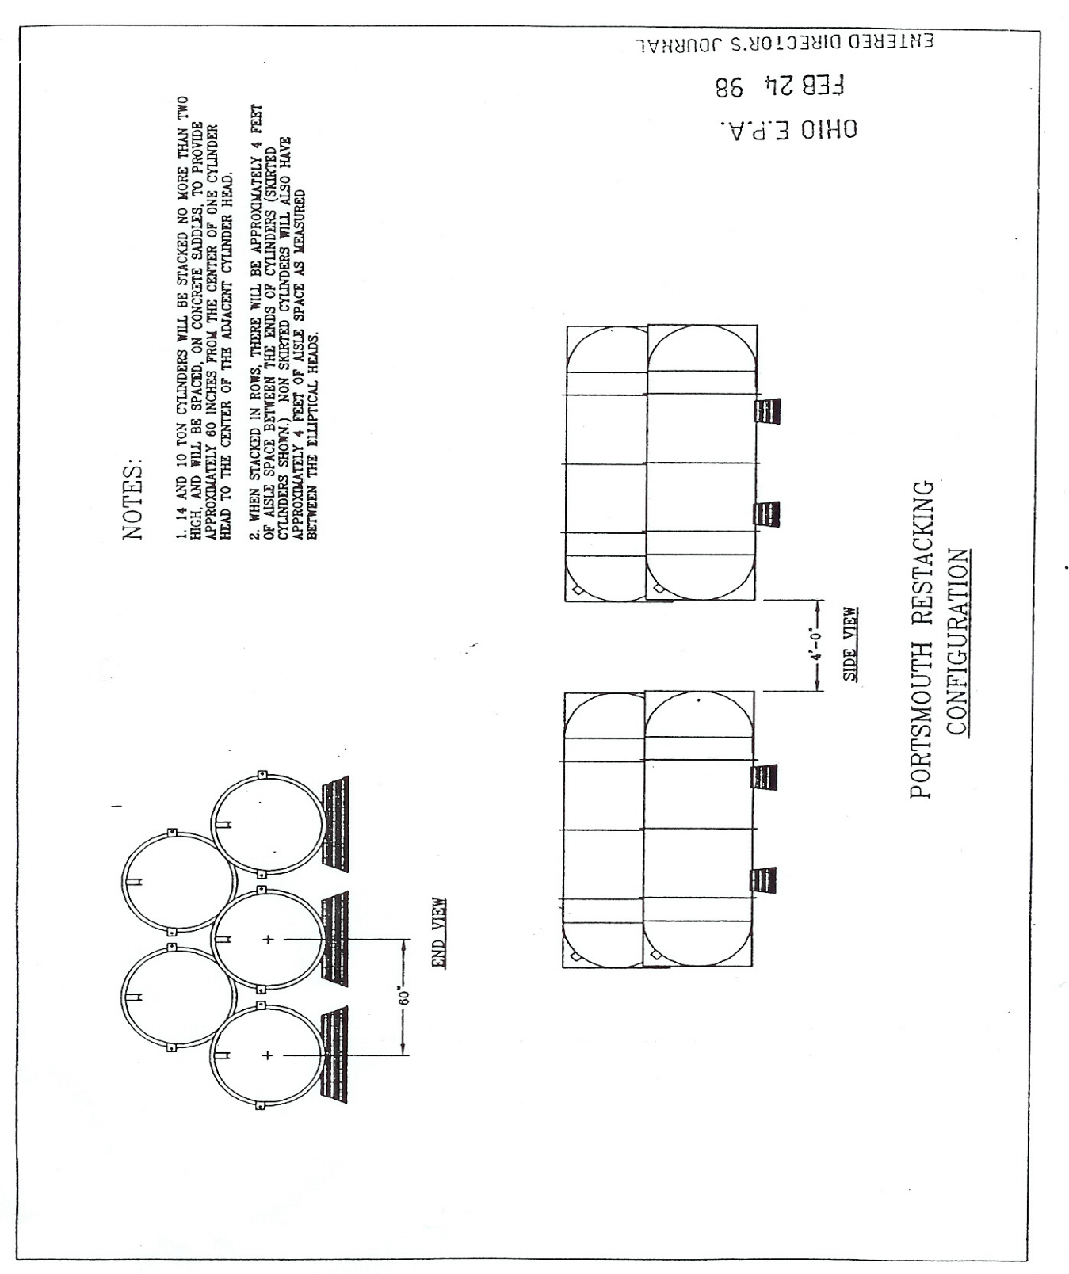
Attachment A, Cylinder Stacking Configuration
Page 1 of 1

Attachment B, UF6 Cylinder Transportation Routes
Page 1 of 1
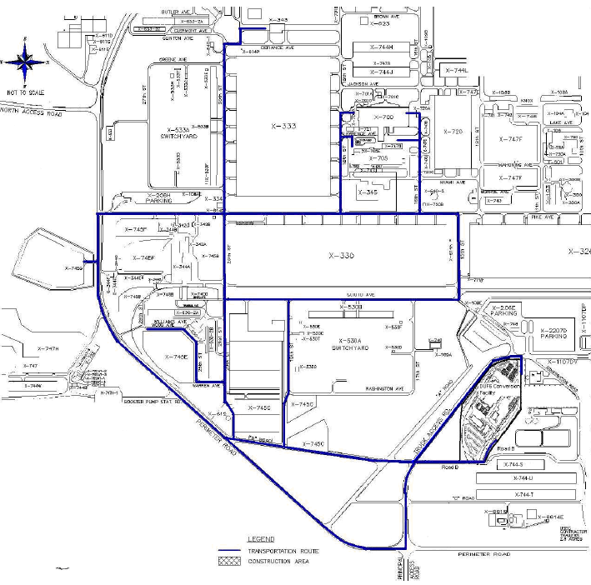

END OF DOCUMENT

